Notebook 1:

Initializing NodeJS Project

**The first thing that you have to do is to download NodeJS to your local machine by going to nodejs.org.**

**Once NodeJS is downloaded, you open Command Prompt and navigate to where you are going to store your program by using the command cd then the location you want to go, like:**





**When you have opened the file where you want to store your project, run the command *npm init,* then follow through and name it what you want to name it.**

**After that, you should make a .html and .js file to run the program off of.**

**That is how you successfully create a NodeJS project.**

**NodeJS .js file coding:**

**First you would have to have the code const http = require(‘http’);. This allows your document to install and pull the module http into the code so you can call it to run your server.**

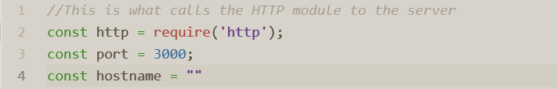**Second you have to identify the hostname and the port of your server so that your computer knows what it is going to be connecting to and it would look like this: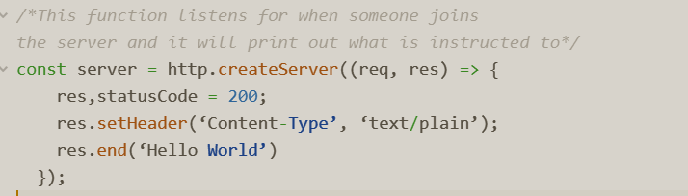 After that you will actually have to define and start your server by running code similar to this:**

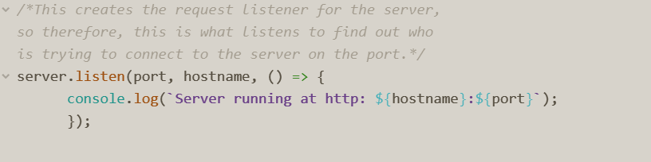 **With the server defined and created all that is left to do is to listen to the server to print out where it is running so you know what to connect to:**

**Once that is all said and done, you can run the command node (name of the .js file) and navigate to localhost:3000 to see your file**

